student attendance management system

FRAMS, a student attendance management system that uses facial recognition to track student attendance

By: Ailly Shilunga gr.10-11

# **TABLE OF CONTENT**

1**Introduction** 2

Description of business/organization 2

Description of problem 2

Specific objects 4

Overall aim 4

**Saving Time and Making Attendance Faster** 4

**Making Attendance More Accurate** 5

**Preventing Cheating and Strengthening Security** 5

**Helping Teachers and Schools Make Smart Decisions** 5

**‍Making the System Easy to Use** 5

**Respecting Privacy and Keeping Data Safe** 5

**Improving the Whole School System** 5

Description of other possible solutions 5

**Evaluation of existing solution** 9

**Design** 11

Action Plan 11

System Flowchart 12

**Method of solution** 13

Hardware requirements 16

**Software requirements** 17

Programing code 19

**Testing** 23

Test strategy 23

Test Results 24

**User Guide** 25

**Evaluation and Development** 26

Evaluation 26

**Opportunities for system development** 27

# **Introduction**

## Description of business/organization

Jan Mohr Secondary School, a prestigious learning institution which aims to facilitate the provision of high-quality education to ensure that students achieve their full academic performance hence, their moto ***‘’Altyd my beste’’***, (Afrikaans for ‘’***Always my best’’***),is institute located in the capital city of Namibia, Windhoek (Windhoek West to be precise).Jan Mohr has a very unique number when it comes to staff, consisting of 3 Secretaries, 4 HOD’s, about 4-5 Sport teachers, 1 librarian and 8 cleaners. In total there are about 58 teachers. The school has 4 laboratories, 1 for Computer Science, 1 for Office practice, 1 Science laboratory and 1 for Biology. The school also has a few sport fields. This institute consists favor’s varies students from grades ranging from gr.8-12. Yearly, the school enrolls about

## Description of problem

Jan Mohr uses a paper based system to track student attendance using manual roll-call as one of their input methods. The current system put to play consist of three major parties: The register teacher, the class monitor of that class and the HOD (Head of department).

Each teacher is assigned a register class and selects their own class monitor depending on the class teacher’s choice after that is therefore handed a register file where they are required to take attendance of the whole week and is required to hand it in at their respected HOD. During this week, the class teacher works hand- in- hand with the class monitor to help track attendance, misbehavior and truancy. The class captain is handed a few class lists in order to take attendance. This class lists are normal class lists that have the names of students, id numbers and the date the class list was printed. These class lists are used for varies purpose such as recording marks, ticking of those who paid for a certain event, and to assign what team the learner will be on for sports day and many others

The class monitor is required to have a class list for their class lists every week as they will as t to take attendance. At the beginning of every first period, the class captain takes attendance of that day using manual roll-call and does so for the rest of the week. At the end of the week the teacher asks for the attendance that the class captain took for that week so that the teacher can update their register. An example of how the register file look like is given below



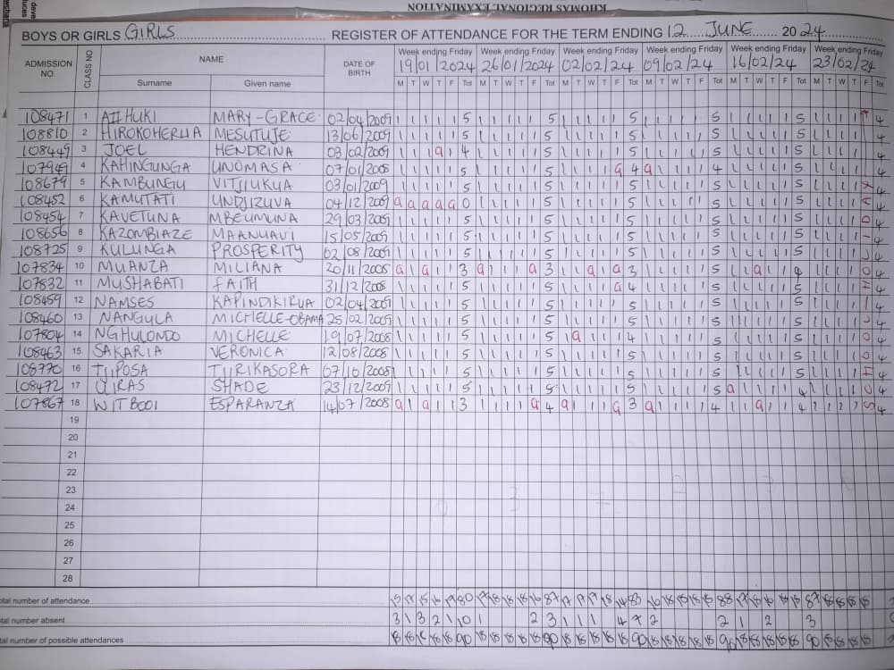

As illustrated above, that is the teacher’s attendance register for 9A that shows the student admission number (ID number), surname, name and date of birth. Each student has their own “row” of their own whereby their attendance is marked for a week (the 1’s or sticks indicate that the student was present that day, the number at the end of each week indicate that the learner was present for i.e. 5 days or 4 days, or 0).

The registers are then handed in on every Friday to the teacher’s respected HOD for further analysis, where the HOD checks if the teacher took attendance of that week and than the HOD checks if there are any suspicious trends in the attendance of the week.

All in all, in many schools, taking attendance is still a manual process. Teachers often rely on paper registers, verbal roll-calls, or spreadsheets to record which students are present, absent, or late. This method is not only time-consuming but also prone to human error, manipulation, and inconsistency. In large classrooms, it can take several minutes just to complete attendance—time that could be better spent on teaching and learning.

Manual attendance also opens the door to dishonest practices. Students may ask friends to sign in for them, or teachers may accidentally mark the wrong student. Over time, these inaccuracies can affect school records, student performance tracking, and even disciplinary decisions.

Another major challenge is the lack of centralized student data. Without a digital system, schools struggle to maintain up-to-date records of who is enrolled, which class they belong to, and how often they attend. This makes it harder to identify students who need support or to generate reliable reports for parents and administrators.

FRAMS (Facial Recognition Attendance Management System) was created to solve these problems. By using facial recognition technology, FRAMS automates the attendance process, ensures accuracy, and encourages proper student registration. It saves time, reduces errors, and helps schools build a more organized and accountable system.

## Specific objects

Overall aim: To fully computerize the current student attendance management system

### **Saving Time and Making Attendance Faster**

Taking attendance manually—calling names, ticking boxes—can take several minutes every class. FRAMS speeds this up dramatically. With facial recognition, students are marked present automatically as soon as they walk in front of the camera. Teachers don’t need to do anything extra. This means more time for teaching and less time wasted on routine tasks.

Key Speed-Boosting Features

* Preloaded Class Roster:  
  Student profiles and face descriptors are loaded on dashboard initialization, so recognition starts immediately without fetching data mid-session.
* Real-Time Face Detection  
  The system scans the webcam feed every second, instantly identifying known faces and marking them present.
* Automatic Status Update  
  once a match is found, attendance is recorded and saved to localStorage with no additional clicks or confirmations.
* Parallel Processing:  
  multiple faces can be detected and matched simultaneously, enabling large classes to be processed in bulk.
* Smart Fall-Back:
* Unrecognized faces are ignored without interrupting the flow, ensuring no delays even when new or unexpected faces appear.

### **Making Attendance More Accurate**

Mistakes happen when attendance is done by hand—names get missed, marked wrong, or forgotten. FRAMS uses each student’s face to match them with their profile, so there’s no confusion. Once a student is recognized, the system updates their status instantly and correctly. This helps keep records clean and trustworthy.

### **Preventing Cheating and Strengthening Security**

Sometimes students ask friends to sign in for them when they’re not really in class. FRAMS stops this kind of cheating. Because it uses live video and facial recognition, only the actual student can be marked present. This helps schools keep honest records and makes sure everyone is treated fairly.

### **Helping Teachers and Schools Make Smart Decisions**

FRAMS doesn’t just take attendance—it also keeps track of patterns. If a student is often late or absent, the system can help teachers spot that early. Over time, schools can use this data to understand which classes have the most absences, which students might need support, and how attendance affects learning.

### **‍Making the System Easy to Use**

FRAMS is built to be simple and friendly. Teachers see clear buttons and color-coded labels for each student. If someone isn’t recognized by the camera, the teacher can still mark them manually with one click. The system works on laptops, desktops, and even tablets, so it fits into any classroom setup.

### **Respecting Privacy and Keeping Data Safe**

FRAMS takes privacy seriously. It doesn’t send student photos to the internet or store them on outside servers. Everything is handled safely inside the school’s system. Students and parents can feel confident that their information is protected and used only for attendance.

### **Improving the Whole School System**

To use FRAMS, every student must be properly registered in the school’s database. This encourages schools to keep accurate records of who is enrolled, which class they’re in, and how they’re doing. Over time, this helps build a stronger, more organized school system where everything is connected—from attendance to performance to support.

## Description of other possible solutions

When exploring ways to improve attendance tracking at the school, three potential approaches were evaluated:

1. **Spreadsheet-Based Attendance System**
2. **Off‑the‑Shelf School Management Software**
3. **Facial Recognition Attendance Management System (FRAMS)**

Each solution was assessed for suitability, efficiency, cost, and potential impact on the school.

**1. Spreadsheet-Based Attendance System**

**Description:**  
Teachers record attendance either manually on paper and later transfer it to a spreadsheet, or directly type it into applications such as Microsoft Excel or Google Sheets. Formulas can be used to calculate totals for present, absent, or late students.

**Advantages:**

* Low cost with no extra software purchase needed
* Easy to set up and familiar to most teachers
* Basic automation possible using built-in formulas
* Can sort and filter data by class, date, or student name

**Disadvantages:**

* Still a time-consuming and partially manual process
* Becomes slow and difficult to manage with large datasets
* No built-in protection against errors or data tampering
* Limited security features and no attendance fraud prevention

**2. Off‑the‑Shelf School Management Software**

**Description:**  
Commercial platforms (e.g., Edupac, Pastel Education) provide ready‑made modules for attendance, grading, timetables, and reporting.

**Advantages:**

* Specifically designed for schools
* Fast and accurate data entry and reporting
* Often comes with technical support and cloud backup
* Can integrate with other administrative tasks such as grading or fees

**Disadvantages:**

* High initial purchase or subscription costs
* Requires user training before effective use
* Limited customization for the school’s exact needs
* Dependent on vendor support and stable internet connection

**3. Proposed Solution: FRAMS (Facial Recognition Attendance Management System)**

**Description:**  
FRAMS uses AI-powered facial recognition to automate the entire attendance process. Once students are registered with their facial profiles, the system instantly identifies and marks them present as they arrive. Attendance data is stored securely and can be accessed in real time.

**Advantages:**

* Fully automated — marks attendance within seconds
* Highly accurate, reducing human errors
* Prevents proxy or false attendance
* Improves the overall school record system by requiring up‑to‑date student registration
* Saves time, allowing teachers to focus on lessons
* Data can be used for analytics and performance tracking

**Disadvantages:**

* Requires initial investment in cameras and supporting hardware
* Needs ongoing system maintenance and software updates
* Privacy concerns require appropriate safeguards and consent management

Summary Table

|  |  |  |
| --- | --- | --- |
| **Solution** | **Advantages** | **Disadvantages** |
| **Spreadsheet-Based Attendance** | - Low cost - Familiar and easy to use - Basic automation with formulas | - Still partly manual - Slows down with large data - No built-in fraud prevention |
| **Off‑the‑Shelf School Management Software** | - Designed for schools - Fast, accurate reports - Includes technical support | - High cost - Requires training - Limited customization - Internet dependent |
| **FRAMS (Proposed Solution)** | Fully automated - Accurate and secure - Prevents attendance fraud - Strengthens entire school record system | - Initial hardware cost - Maintenance required - Must manage privacy safeguards |

## **Evaluation of existing solution**

In many schools, attendance is still recorded using traditional methods such as paper registers, verball roll-calls, or spreadsheet-based systems. These approaches have been used for decades and are familiar to most teachers and administrators. While they may seem simple and cost-effective, they come with several limitations that affect accuracy, efficiency, and the overall management of student data.

**✅ Advantages of the Current System**

1. **Simplicity and Familiarity**  
   Teachers are already trained to use manual registers or spreadsheets, so no additional technical skills are required. This makes the system easy to adopt and maintain without specialized equipment.
2. **Low Initial Cost**  
   Paper registers and basic spreadsheet tools require minimal investment. Schools don’t need to purchase hardware or software licenses to implement them.
3. **Offline Accessibility**  
   Manual systems do not rely on internet connectivity or power supply. Attendance can be taken in any classroom, regardless of technical infrastructure.
4. **Flexibility in Recording Notes**  
   Teachers can jot down comments, reasons for absence, or other observations directly on paper, which may feel more personal and adaptable than digital systems.

**❌ Disadvantages of the Current System**

1. **Time-Consuming Process**  
   Calling out names and manually marking attendance can take several minutes per class, especially in large groups. This reduces valuable teaching time and can cause delays in lesson delivery.
2. **Prone to Human Error**  
   Mistakes such as marking the wrong student, skipping names, or forgetting to update records are common. These errors can lead to inaccurate reports and confusion during audits.
3. **Lack of Real-Time Data**  
   Manual records are not instantly accessible to administrators or parents. Teachers often need to submit attendance at the end of the day or week, which delays interventions for absent students.
4. **Risk of Manipulation or Proxy Attendance**  
   Students may ask friends to sign in for them, especially when using paper registers. This undermines the integrity of the attendance system and makes it difficult to track genuine participation.
5. **Storage and Retrieval Issues**  
   Paper records can be lost, damaged, or difficult to organize over time. Retrieving historical attendance data for a specific student or class can be tedious and unreliable.
6. **Limited Integration with School Systems**  
   Manual attendance is often disconnected from other school databases such as grading systems, student profiles, or disciplinary records. This makes it harder to analyze trends or generate comprehensive reports.

**Justification of the Proposed Solution: FRAMS**

The **Facial Recognition Attendance Management System (FRAMS)** stands out as the most effective option because it directly addresses the limitations of the other methods and aligns with the school’s long‑term goals.

**1. Efficiency & Time-Saving**

Unlike manual or semi‑automated systems, FRAMS marks attendance within seconds. This means teachers reclaim valuable classroom time to focus on teaching rather than record‑keeping.

**2. Accuracy & Fraud Prevention**

Facial recognition eliminates errors from manual entry and stops cases of proxy attendance (students answering for absent classmates). This strengthens the credibility of attendance records.

**3. Data Security & Accessibility**

Records are stored in a secure database, with role‑based access controls. Authorized staff can view real‑time attendance reports from anywhere with permission.

**4. Long‑Term Cost Effectiveness**

Although there is an initial hardware and setup cost, FRAMS reduces the ongoing labor cost associated with paper‑based or manual systems. Maintenance costs are predictable and can be budgeted annually.

**5. Supports Wider School Modernization**

FRAMS can integrate with other digital systems — such as grading, reporting, and ID card management — contributing to the school’s overall digital transformation strategy

📌 Summary

While the current attendance system is simple and widely used, it falls short in areas that matter most—speed, accuracy, security, and data management. As schools grow and technology becomes more accessible, there is a clear need for a smarter, more reliable solution that can automate attendance, reduce errors, and integrate seamlessly with the broader school system.

# **Design**

## Action Plan

The implementation of the Facial Recognition Attendance Management System (FRAMS) will be guided by both computer‑related and business‑related objectives. On the technical side, the system aims to automate attendance marking, ensure secure storage of records, and deliver real‑time reporting. From a business perspective, it is designed to enhance operational efficiency, reduce administrative workload, and provide accurate and timely data to support decision‑making. The action plan that follows aligns closely with the prepared Gantt chart, ensuring each phase and task is strategically scheduled and fully traceable.

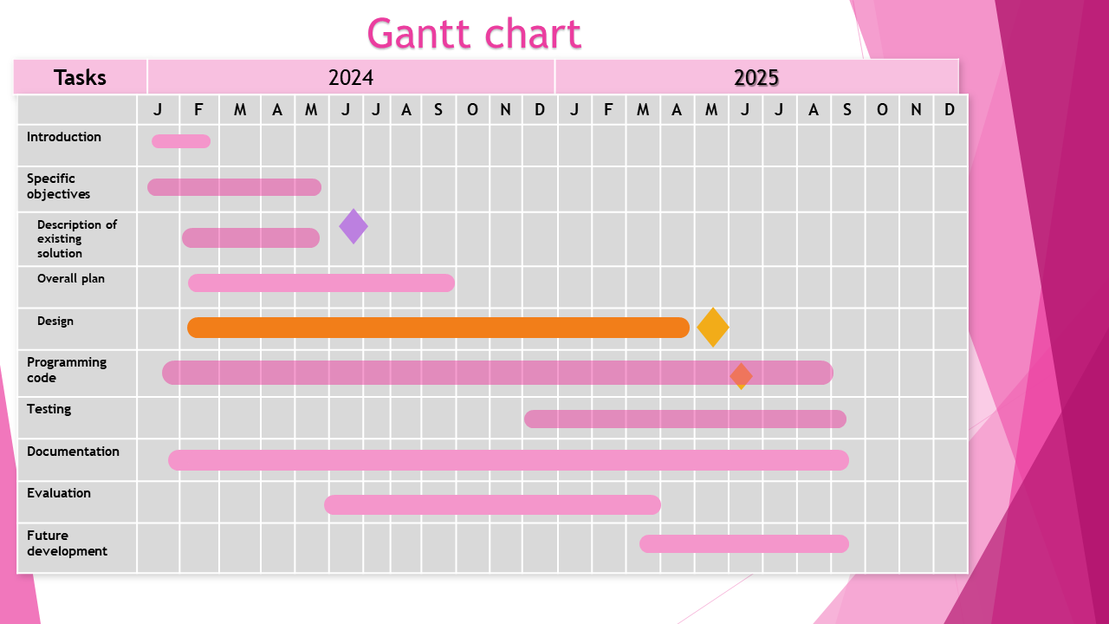

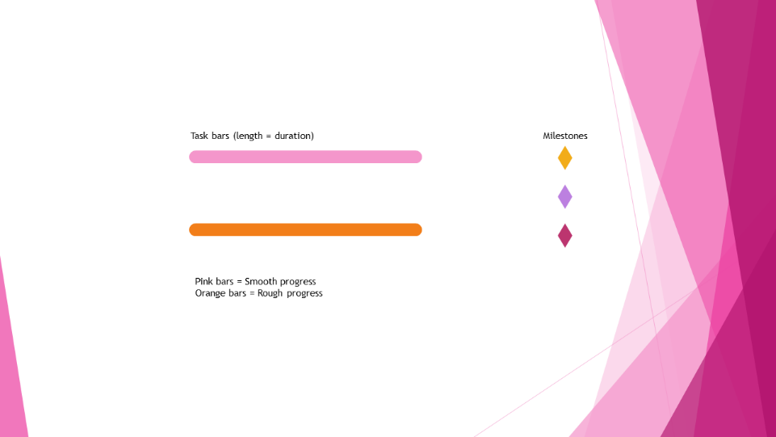

## System Flowchart

The system begins with a login screen. If credentials are valid, the user accesses the dashboard. From there, they can initiate live attendance, where facial recognition scans students. If a face matches, attendance is marked; if not, it's logged as unknown. Teachers can also manually manage attendance. The session ends with logout, returning to the login screen.

## **Method of solution**

The **Facial Recognition Attendance Management System (FRAMS)** is a custom‑built, computerized system designed to automate, secure, and streamline the process of recording student attendance in schools. The solution directly addresses the limitations of manual and semi‑manual attendance methods by leveraging **artificial intelligence** and **facial recognition technology** to accurately verify a student’s presence in real time.

At its core, FRAMS uses a **web‑based interface** accessible on the school’s existing computers or laptops. It integrates with a camera or webcam to capture live facial images of students as they enter a classroom. The system compares each captured image to pre‑registered facial profiles stored in its secure database, and upon a successful match, automatically updates the attendance record for that student. This process takes less than a second per student, allowing the entire class attendance to be completed within moments, even in large groups.

**Registration and Setup**

Before FRAMS can be used for daily attendance, all students must be formally registered in the school’s database. This includes capturing each student’s:

* Full name and unique student ID
* Class allocation (grade, subject groups, or sections)
* Facial profile images taken from multiple angles
* Additional demographic details (optional, e.g., contact information for reports)

This registration process ensures the school maintains an **accurate and up‑to‑date centralised record** of every enrolled student. It also reinforces the integrity of the wider school system by requiring proper enrolment before attendance can be marked.

**Login and Access Control**

Teachers and authorised staff log in to FRAMS using unique usernames and secure passwords. Access levels can be configured so that:

* Teachers can only view and update attendance for their own classes
* Administrators can access and analyse attendance data across the school
* System operators can manage hardware, update student records, and configure facial recognition settings

This layered access structure protects sensitive data and ensures compliance with privacy requirements.

**Attendance Capture Methods**

FRAMS offers two attendance modes:

1. **Live Facial Recognition Mode** – The system uses the connected camera to continuously scan and detect faces in real time. Recognised students are automatically marked as “Present,” with a timestamp recorded. Multiple students can be detected in a single frame, enabling extremely fast attendance marking.
2. **Manual Override Mode** – In cases where a student’s face is not recognised (e.g., wearing a mask, lighting issues), the teacher can manually mark the student as Present, Absent, or Late with a single click. This ensures flexibility and prevents disruption to lessons.

**Data Processing and Storage**

Captured attendance data is processed instantly and stored in the system’s secure database or local storage, with the following details:

* Student ID
* Date and time of attendance marking
* Attendance status (Present, Absent, Late)
* Teacher or staff member who recorded it
* Method of marking (Automatic via recognition / Manual)

These records are indexed for fast searching and retrieval, supporting quick queries such as:

* All absences for a given date
* Attendance history for a specific student
* Monthly attendance summaries for a class

**Reports and Outputs**

FRAMS can generate detailed attendance reports, which may include:

* Daily, weekly, and monthly summaries
* Class and subject attendance patterns
* Individual student attendance history
* Statistical insights such as absence percentages and punctuality trends

Reports can be viewed on‑screen, printed, or exported for further analysis. Colour‑coded dashboards provide teachers with an at‑a‑glance view of current class attendance.

**Security and Data Integrity**

Security is integral to FRAMS. All facial data is stored securely, with encryption applied where possible to protect biometric information. Role‑based access prevents unauthorised data viewing or editing. System activity logs ensure any changes are traceable for accountability.

**Integration and Scalability**

FRAMS can be scaled to suit a single class, a whole school, or even multiple campuses. The modular design allows future integration with:

* School management systems
* Student performance tracking tools
* Automated parent notification systems for absences

**Overall Benefits**

By replacing slow, error‑prone manual methods with automated recognition, FRAMS:

* Saves significant classroom time
* Provides highly accurate, verifiable records
* Eliminates proxy attendance fraud
* Encourages proper registration of all students in the school system
* Generates real‑time insights for better decision‑making

In essence, FRAMS is not just an attendance tool — it is a complete **digital attendance ecosystem**, ensuring efficiency, accuracy, and integrity in school record‑keeping while setting a strong foundation for broader digital transformation.

## Hardware requirements

The **Facial Recognition Attendance Management System (FRAMS)** requires a reliable combination of hardware components to ensure smooth operation, accurate facial recognition, and secure data storage. All devices listed below are directly necessary for the running of the system — there are no redundant or unnecessary items included. Each device serves a specific function in capturing, processing, storing, or displaying attendance information.

**Desktop or Laptop Computer**

The main platform for running FRAMS will be a desktop or laptop computer located in each classroom or at a designated attendance station.  
**Reason 1:** Provides sufficient processing power and memory to run the facial recognition software in real time without delays.  
**Reason 2:** Acts as the control hub, allowing the teacher to log in, view live recognition results, and generate attendance reports instantly.

**Webcam or HD Camera**

A webcam or high-definition camera is essential for capturing live images of students as they enter the classroom.  
**Reason 1:** Provides the video feed required for the AI-powered recognition algorithm to detect and match student faces accurately.  
**Reason 2:** Ensures image clarity and resolution suitable for accurate recognition under varying classroom lighting conditions.

**Local Server or Secure Storage Device**

Depending on the size of the school, attendance data and biometric templates will be stored securely either on a local server or a dedicated storage drive.  
**Reason 1:** Provides a secure, centralised location for all attendance records, ensuring data integrity and availability.  
**Reason 2:** Allows for regular backups to prevent data loss in case of device failure.

**Reliable Network Connection (LAN/Wi‑Fi)**

A stable wired or wireless network connection supports FRAMS functionality.  
**Reason 1:** Allows attendance data to sync in real time with the school’s administrative system for instant updates.

**Reason 2:** Enables secure communication between the classroom device and the central database for reporting and analysis.

**UPS (Uninterruptible Power Supply)**

A UPS is required to keep the computer and camera running during short power outages.  
**Reason 1:** Prevents disruption of the attendance process caused by unexpected power cuts.  
**Reason 2:** Protects sensitive hardware from damage due to sudden shutdowns or power surges.

|  |  |  |
| --- | --- | --- |
| **Hardware Device** | Reason 1 | Reason 2 |
| **Desktop/Laptop Computer** | Runs FRAMS software and recognition engine | Allows teachers to log in, monitor recognition, and generate reports |
| **Webcam/HD Camera** | Captures video feed for recognition | Ensures clear images for accurate detection |
| **Local Server / Secure Storage** | Centralised, secure attendance data storage | Enables regular backups and data protection |
| **Network Connection** | Syncs attendance data in real time | Connects devices to central database |
| **UPS (Power Backup)** | Maintains operation during short outages | Protects devices from sudden power loss |

**Hardware Summary Table**

|  |  |  |
| --- | --- | --- |
|  |  |  |
|  |  |  |
|  |  |  |
|  |  |  |
|  |  |  |

## **Software requirements**

The successful implementation and operation of the Facial Recognition Attendance Management System (FRAMS) requires specific software components. Each software item listed below has been selected to ensure smooth performance, strong security, and full compatibility with the system’s objectives. There are no unnecessary items — all software directly supports the core functionality of FRAMS.

**1. Operating System**

The recommended operating system for FRAMS is **Windows 10 or Windows 11**.  
**Reason 1:** It provides a stable and reliable environment with built‑in support for modern web browsers, camera drivers, and AI processing libraries needed for facial recognition.  
**Reason 2:** Windows is widely used in educational institutions, which ensures compatibility with existing school infrastructure and makes it easier for staff to adapt to the system.

**2. Application Software**

The core FRAMS interface will run within a **modern web browser** such as **Microsoft Edge** or **Google Chrome**. F**ace‑api.js** (Version 0.22.2)  
Edge and Chrome provide the WebRTC and WebGL capabilities needed for in‑browser real‑time face recognition. **face‑api.js v stable release for0.22.2** is the most accurate facial detection and matching without server‑side processing.

**Reason 1:** These browsers support the latest web technologies (HTML5, JavaScript, WebRTC) which are essential for real‑time camera access and face recognition processing in the browser.  
**Reason 2:** They allow FRAMS to be platform‑independent on the front‑end, enabling easy updates and eliminating the need for complex local installations on every machine.

Additionally, **JavaScript runtime environments** (such as Node.js) may be used on the backend if the system is extended for centralised hosting, enabling smooth handling of data processing requests.

**Anti‑Virus Software**

A reputable anti‑virus program (e.g., **Microsoft Defender** or **Avast**) is essential.  
**Reason 1:** It safeguards the system from malware or viruses that could compromise attendance records or disrupt the recognition software.  
**Reason 2:** It protects both student data and biometric information from cyber threats, ensuring compliance with privacy and security policies.

**4. Drivers and Supporting Software**

**Camera drivers** and related utilities must be installed for the webcam or camera hardware to function correctly.  
**Reason 1:** Drivers enable the operating system and browser to communicate directly with the camera, ensuring smooth video feed capture for the recognition process.  
**Reason 2:** Updated drivers improve compatibility, performance, and image quality, which directly impacts the accuracy of the facial recognition algorithm.

Logitech Capture.11) — for Logitech webcams like the C920 series

**NVIDIA GeForce** (Version 552. Game Ready Driver44) — if using NVIDIA GPUs for accelerated image processing

**Intel Graphics Driver** (Version for Intel integrated 31.0.101.5333) — graphics  
These ensure webcams deliver stable, high‑definition video to the browser, and that GPU acceleration works correctly for AI tasks.

Where needed, **graphics drivers** should also be up‑to‑date to support accelerated image processing.

**Software Summary Table**

|  |  |  |
| --- | --- | --- |
| **Software Type** | **Technical Specification** | **Reasons for use** |
| **Operating System** | Microsoft Windows 11 Pro (64-bit) | -Stable, secure environment with camera & AI support  - Widely used in schools for compatibility |
| **Application Software** | Microsoft stack; strong security Edge v126+ / Google Chrome v126+ + face‑api.js v0.22.2 | -Supports modern web tech for recognition  -Easy updates, no complex installation |
| **Anti‑Virus 6** | Defender AV (Platform Avast Premium Security 4.18.24050.7) / v24. | -Protects from malware & cyber threats  -Secures sensitive biometric and attendance data |
| **Drivers** | Logitech + NVIDIA GeForce GRD v552.44 / Intel Graphics Driver v31.0.101.5333 | - Ensures HD webcam output and optimised GPU acceleration for facial recognition performance. |

# Programing code

Below are codes for all my pages;

Login-Signup.

<!-- index.html, styles css and java script -->

<!-- This page handles login for existing teachers and signup for new teachers -->

<!DOCTYPE html>

<html lang="en">

<head>

  <meta charset="UTF-8">

  <title>Teacher Dashboard</title>

  <link rel="stylesheet" href="style.css">

  <style>

    .center-header {

      text-align: center;

      padding: 2rem 1rem;

      color: black;

    }

    .center-h1 {

      text-align: center;

      font-size: 2rem;

      margin-top: 1rem;

      color: black;

    }

    .center-buttons {

      display: flex;

      flex-direction: column;

      align-items: center;

      gap: 1rem;

      margin-top: 2rem;

    }

    .center-buttons button {

      background: orange;

      color: #fff;

      border: none;

      padding: 0.8rem 1.5rem;

      font-size: 1rem;

      border-radius: 8px;

      cursor: pointer;

      width: 80%;

      max-width: 300px;

      transition: background 0.3s;

    }

    .center-buttons button:hover {

      background: dodgerblue;

    }

    .back-button {

      background: orange;

      margin-top: 2rem;

    }

    .back-button:hover {

      background: dodgerblue;

    }

  </style>

</head>

<body>

    <a href="index.html" class="home-button">🏠Home</a>

  <header class="center-header">

    <img src="assets/logo.jpeg.jpg" alt="FRAMS Logo" class="logo">

    <h1>Welcome to FRAMS</h1>

    <p>Facial Recognition Attendance Management System</p>

  </header>

  <h1 class="center-h1">Teacher </h1>

  <div class="center-buttons">

    <button onclick="location.href='teacher-signup.html'">📝 Sign Up</button>

    <button onclick="location.href='teacher-login.html'">🔐 Log In</button>

  </div>

</body>

</html>

<!-- index.html -->

<!-- This page handles login for existing teachers and signup for new teachers -->

<!DOCTYPE html>

<html lang="en">

<head>

  <meta charset="UTF-8">

  <title>FRAMS Dashboard</title>

  <link rel="stylesheet" href="style.css">

  <style>

    /* Top-right nav buttons */

    .nav-buttons {

      position: absolute;

      top: 20px;

      right: 20px;

      display: flex;

      gap: 10px;

    }

    .nav-button {

      background-color: orange;

      color: #333;

      padding: 10px 20px;

      border-radius: 25px;

      text-decoration: none;

      font-weight: bold;

      box-shadow: 0 4px 6px rgba(0,0,0,0.1);

      transition: background-color 0.3s ease, transform 0.2s ease;

    }

    .nav-button:hover {

      background-color: orange;

      transform: scale(1.05);

    }

    /* Centered form container */

    .form-wrapper {

      display: flex;

      justify-content: center;

      align-items: center;

      height: 100vh;

      flex-direction: column;

    }

    .form-container {

      width: 360px;

      padding: 2rem;

      background: #fff;

      border-radius: 8px;

      box-shadow: 0 6px 12px rgba(0,0,0,0.1);

      text-align: center;

    }

    .form-container h2 {

      margin-bottom: 1rem;

    }

    .form-container input {

      width: 100%;

      padding: 10px;

      margin: 8px 0;

      border-radius: 5px;

      border: 1px solid #ccc;

      box-sizing: border-box;

    }

    .form-container button {

      width: 100%;

      padding: 12px;

      margin-top: 12px;

      background-color: orange;

      color: #fff;

      border: none;

      border-radius: 5px;

      cursor: pointer;

      font-size: 1rem;

    }

    .form-container button:hover {

      background-color: #005fa3;

    }

    .toggle-container {

      text-align: left;

      font-size: 0.9rem;

      color: #555;

      margin: -4px 0 12px;

    }

    .forgot-link {

      display: block;

      margin-top: 12px;

      font-size: 0.9rem;

      color: dodgerblue;

      text-decoration: none;

    }

    .forgot-link:hover {

      text-decoration: underline;

    }

    .center-header {

      text-align: center;

      margin-bottom: 2rem;

    }

    .logo {

      display: block;

      margin: 0 auto 1rem auto;

      max-height: 120px;

    }

  </style>

</head>

<body>

  <!-- Top-right buttons -->

  <div class="nav-buttons">

    <a href="index.html" class="nav-button">🏠 Home</a>

    <a href="Login-signup.html" class="nav-button">🔙 Back</a>

  </div>

  <!-- Centered form and header -->

  <div class="form-wrapper">

    <header class="center-header">

      <img src="assets/logo.jpeg.jpg" alt="FRAMS Logo" class="logo">

      <h1>Welcome to FRAMS</h1>

      <p>Facial Recognition Attendance Management System</p>

    </header>

    <div class="form-container">

      <h2>🔐 Log In</h2>

      <form id="loginForm">

        <input type="text" id="username" placeholder="Username" required>

        <input type="password" id="password" placeholder="Password" required>

        <div class="toggle-container">

          <label>

            <input type="checkbox" id="togglePassword"> Show Password

          </label>

        </div>

        <button type="submit">Log In</button>

        <a href="forgot-password.html" class="forgot-link">Forgot Password?</a>

      </form>

    </div>

  </div>

  <script>

  // Show/hide password

  document.getElementById("togglePassword").addEventListener("change", function() {

    document.getElementById("password").type = this.checked ? "text" : "password";

  });

  // Login logic

  document.getElementById("loginForm").addEventListener("submit", function(e) {

    e.preventDefault();

    const username = document.getElementById("username").value.trim();

    const pwd = document.getElementById("password").value.trim();

    const teachers = JSON.parse(localStorage.getItem("teachers")) || [];

    const teacher = teachers.find(t => t.username === username && t.password === pwd);

    if (teacher) {

      localStorage.setItem("currentTeacher", JSON.stringify(teacher));

      alert("Welcome, " + teacher.Surname.Name + "!");

      location.href = "teacher.html"; // ✅ Redirect to teacher.html

    } else {

      alert("❌ Invalid credentials. Try again or click 'Forgot Password?'");

    }

  });

</script>

</body>

</html>

<script defer src="app.js"></script>

The login page:

# **Testing**

## Test strategy

## Test Results

# **User Guide**

# **Evaluation and Development**

## Evaluation

# **Opportunities for system development**

• Automated notifications to students or guardians when absences occur

* API hooks for learning-management systems, syncing grades and attendance
* Edge-computing modules for offline or low-bandwidth environments
* Mobile-app extensions enabling hybrid classrooms and remote proctoring

These enhancements will not only extend FRAMS’s capability but will also foster a more connected, insight-driven educational ecosystem.